**Multi Modal Interactive Paint – Manual Installation Guide (OLD)**

Project Installation Directions:

Hardware Needed:

* Acer Multitouch Screen
* Intel Real Sense Camera
* Tobii EyeX
* Leap Motion
* Personal computer (core i5 or higher)

Software Needed:

* Windows 10 OS
* Microsoft Visual Studio 2013 with C++11
* Leap Motion SDK
* Tobii EyeX SDK
* Intel Real Sense SDK
* LIBUSB 1.0 SDK
* Libcinder

**Note: Use Visual Studio 2015 with Update 3**

Microsoft Visual Studio 2013 Installation:

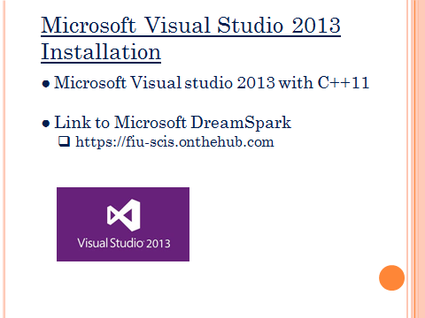

* Follow link provided and following homepage should appear as seen below.

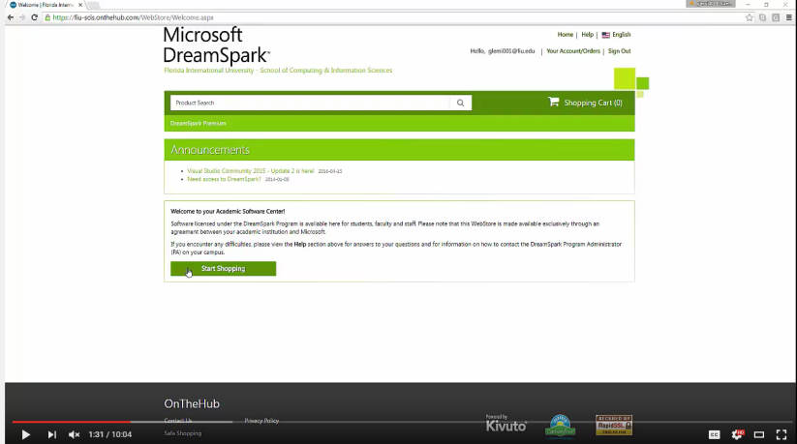

* Now press start shopping button to proceed to the shopping section of dream sparks the following screen should appear.

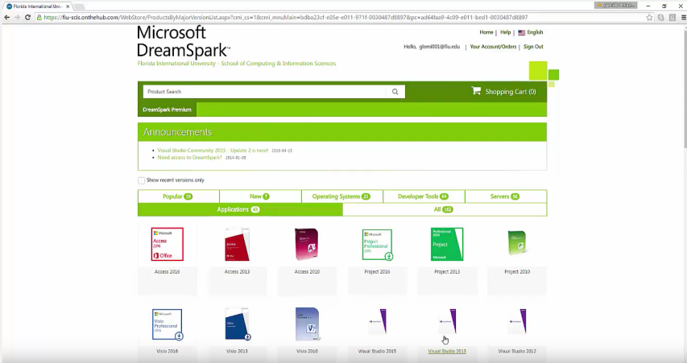

* Selection application button highlighted in green in the screenshot above and then proceed to Visual Studio 2013 button displayed in lower right hand corner of screenshot above.

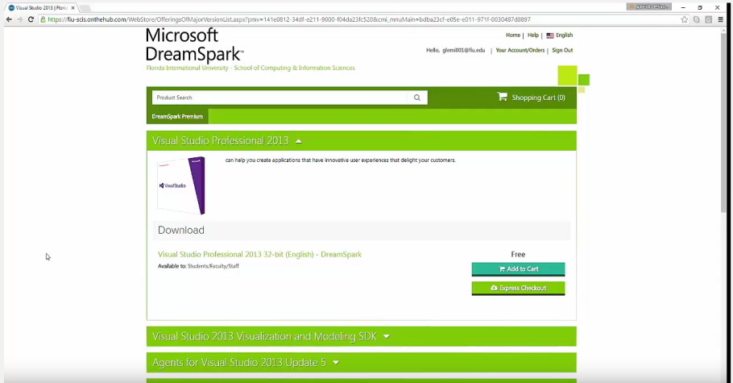

* Now proceed to add to cart and checkout. Program should be free if you have a valid FIU account and currently enrolled.
* Once downloaded following Visual Studio installation instructions.

Leap Motion SDK Installation:

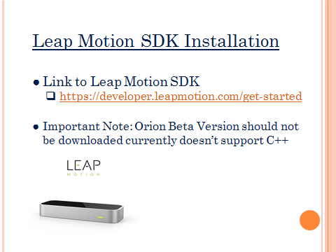

* Follow link provided and following homepage should appear as seen below.

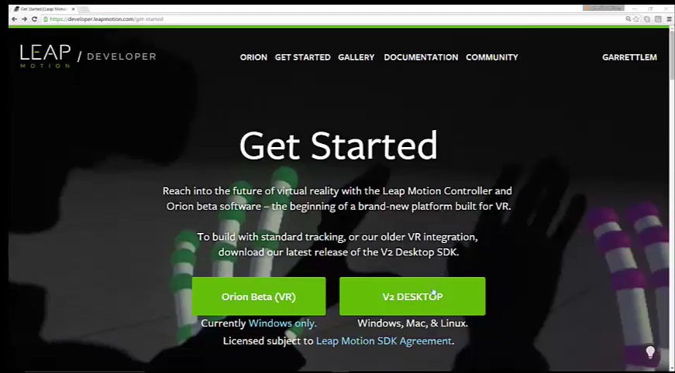

* User must first create an account with leap motion
* Once account is created user presses on V2 Desktop link as seen above.
* The link will take you to the following screen where the SDK can be downloaded.

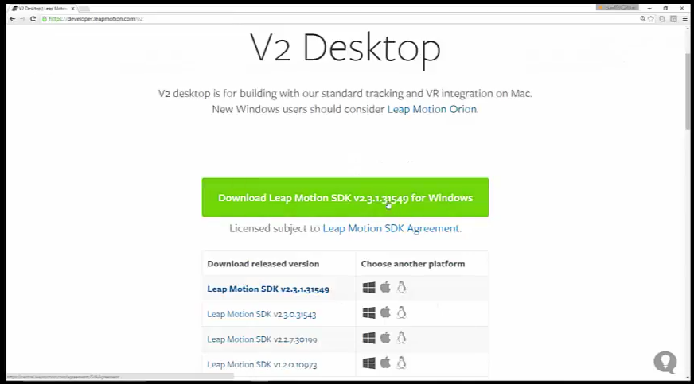

* Before download SDK create a new folder that will hold all the files for the entire project.
  + By downloading all the SDK’s into this folder it will be easier to link the project later on.
* Download Leap Motion SDK v2.3.1.31549 for Windows.
* Once leap motion zip is downloaded extract all files to new folder.
  + Leap motion provides installation software.

Tobii EyeX SDK Installation:

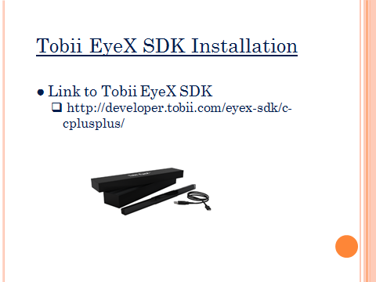

* Follow link provided and following page should appear as seen below.

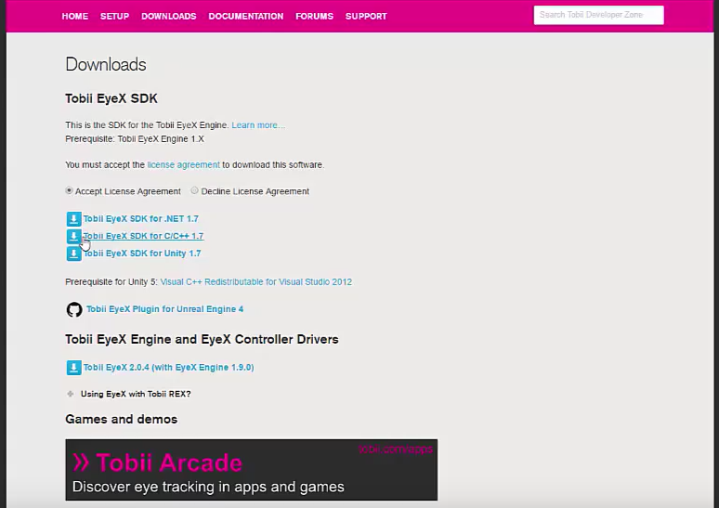

* Again you must create an account with Tobii EyeX
* Press link labeled button Tobii EyeX SDK for C/C++ 1.7
* It will take you to the following page

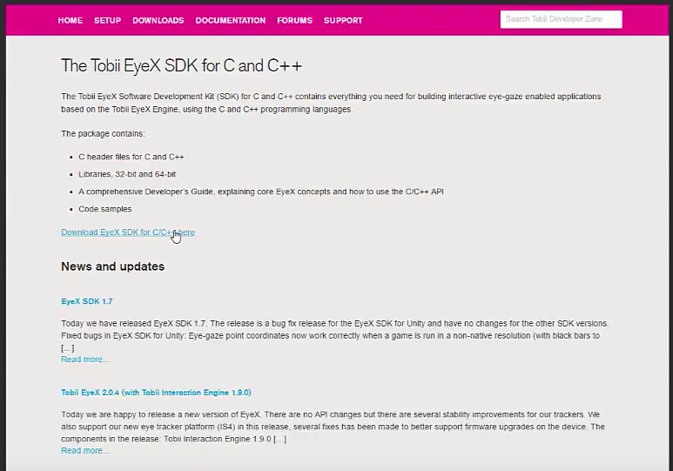

* Select the Download EyeX SDK link for C/C++ as shown above.
* Remember to download into the new folder created earlier or keep track of file location for later.

Intel Real Sense SDK Installation:

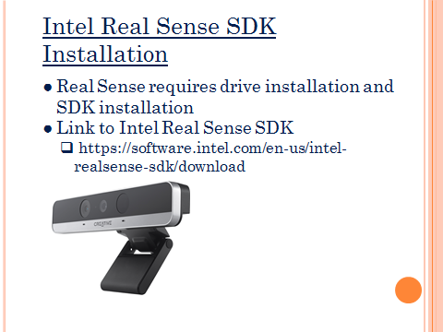

* Follow link provided and following page should appear as seen below.

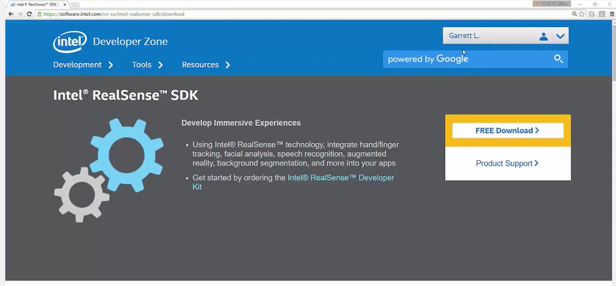

* Need to create an account in order to download SDK
* Once account created go to the free download button on right hand side of screen in screenshot shown above.
* Intel Real Sense Device requires a driver and SDK to be installed.
* When new page appears scroll down to install driver as shown below
  + Note we used model SR300 Camera.

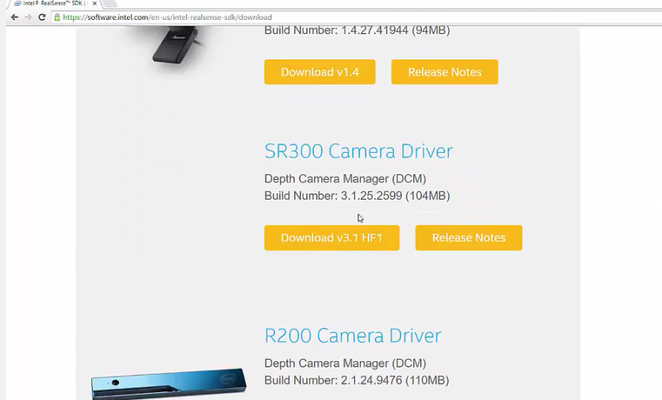

* Next install the Real Sense SDK
* On same page scroll further down until you see download button for real sense SDK.
  + Shown Below

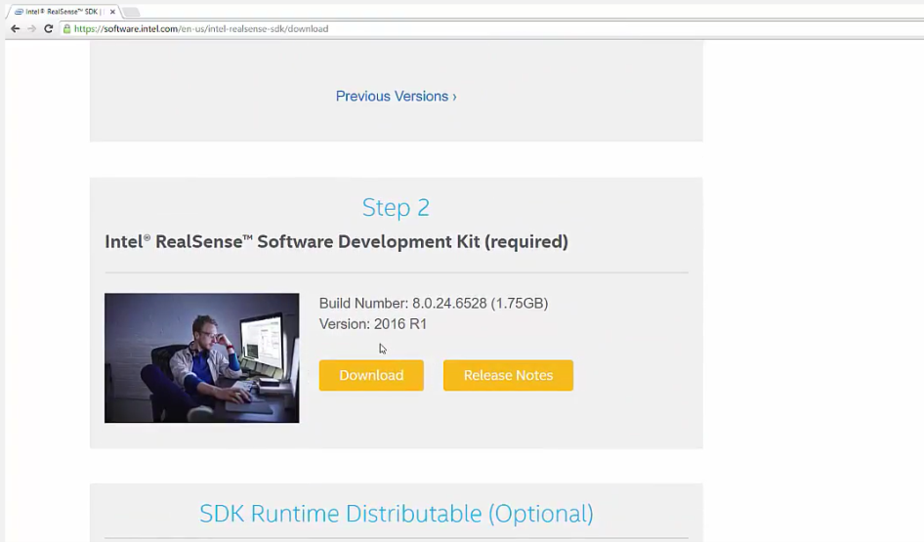

* Remember file location

LibCinder Installation:

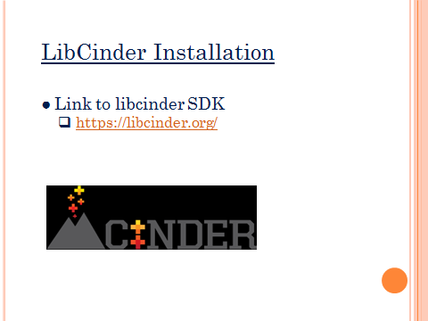

* The link above should take you to the following homepage.



* Once on the homepage press the download button in the upper right hand corner, as displayed in screenshot above.
* Following page should appear.

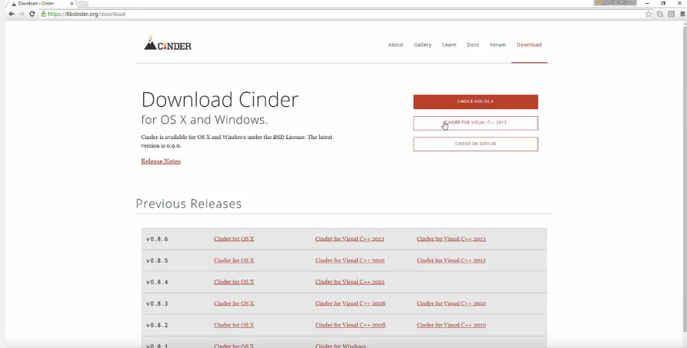

* Press button labeled Cinder for Visual Studio C++ 2013
* Extract all files into desired folder location.

LIBUSB 1.0 SDK Installation:

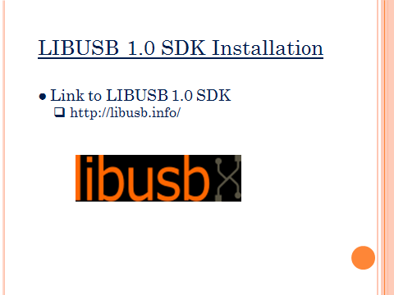

* The link above should take you to the following homepage.

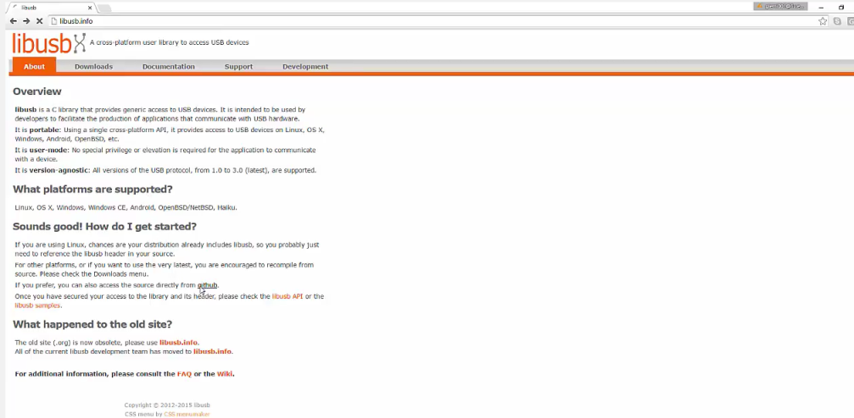

* Source will be obtained directly from GitHub.
* Following the link labeled GitHub as shown in page above.
* Following GitHub page should appear.

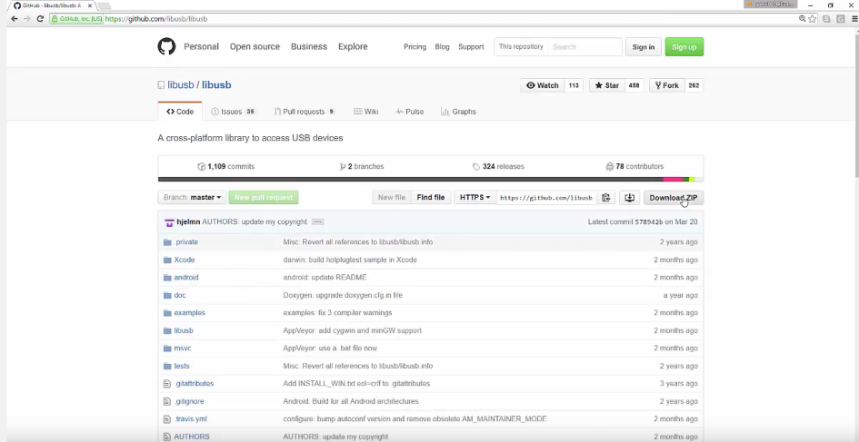

* Select the Download Zip as shown below and place in desired folder.

Now all required software has been downloaded and must open the visual studio solution and link the project correctly.

* Open visual studio solution:
* Go to the folder the Interactive paint zip was extracted to.
* Following the following path /InteractivePaint/Code/TouchPoints/vc2013
  + Make sure visual studio 2013 is default application
  + Then press TouchPoints.sln file as shown below

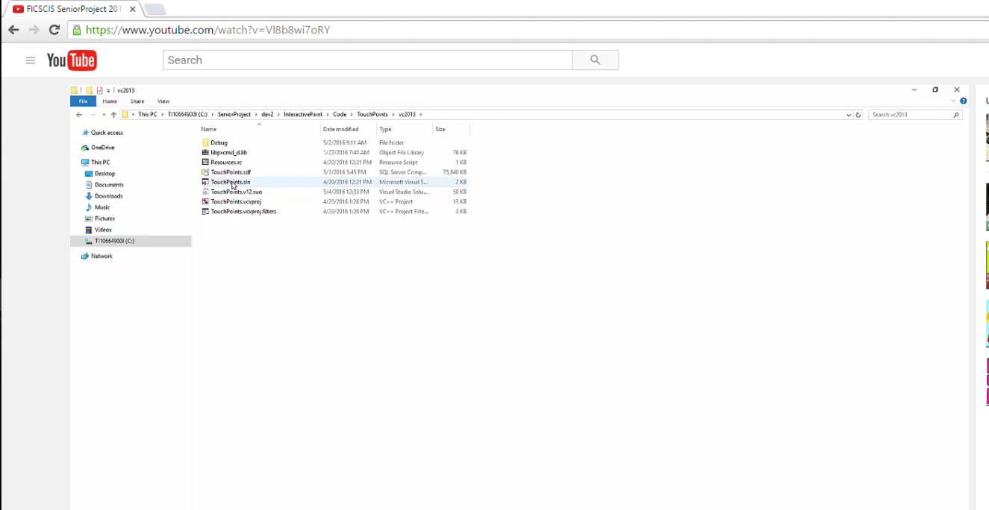

* Now visual studio should open the solution and we need to add the ‘additional include directories’ for all SDKs.
* Go to solution explorer in the right hand side of screen and right click the TouchPoints project and select properties as shown below.

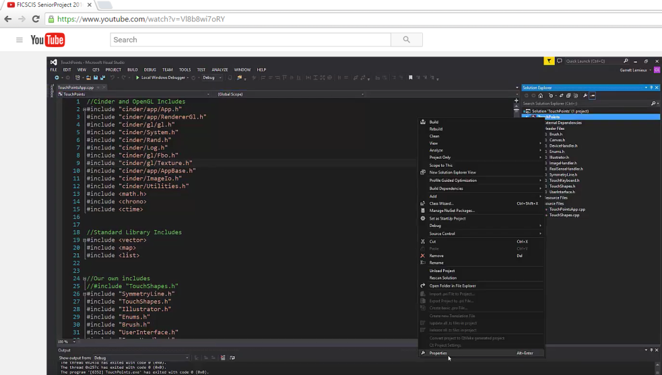

* Proceed to configurationproperties>>C/C++ >>General>> Additional Includes and select edit as shown below.

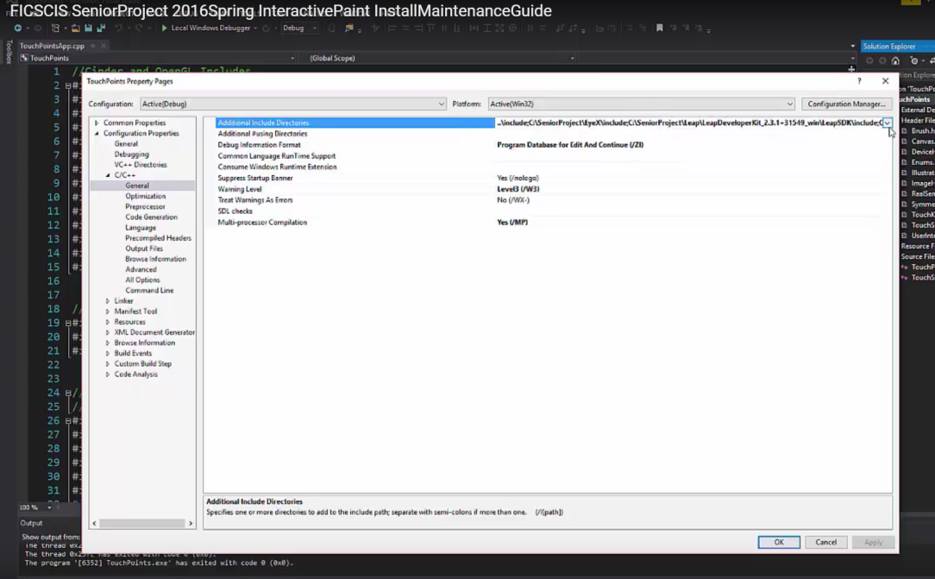

* The following include paths must be added
  + C:\SeniorProject\EyeX\include
  + C:\SeniorProject\Leap\LeapDeveloperKit_2.3.1+31549_win\LeapSDK\include
  + C:\SeniorProject\cinder_0.9.0_vc2013\include
  + C:\SeniorProject\LibUsb\libusb\libusb
  + C:\Program Files %28x86%29\Intel\RSSDK\include
  + Shown below

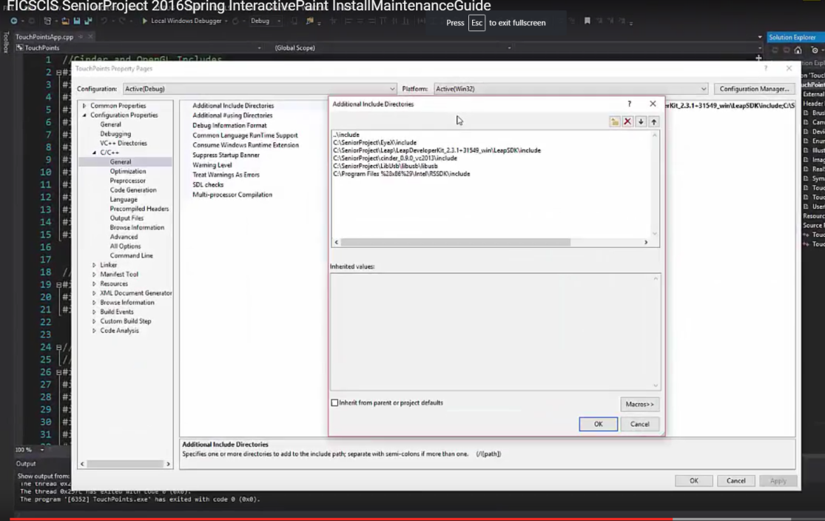

* Now we need to link all the libraries
* Proceed to configurationproperties>>Linker>>General>Additional libraries directories
* As shown below

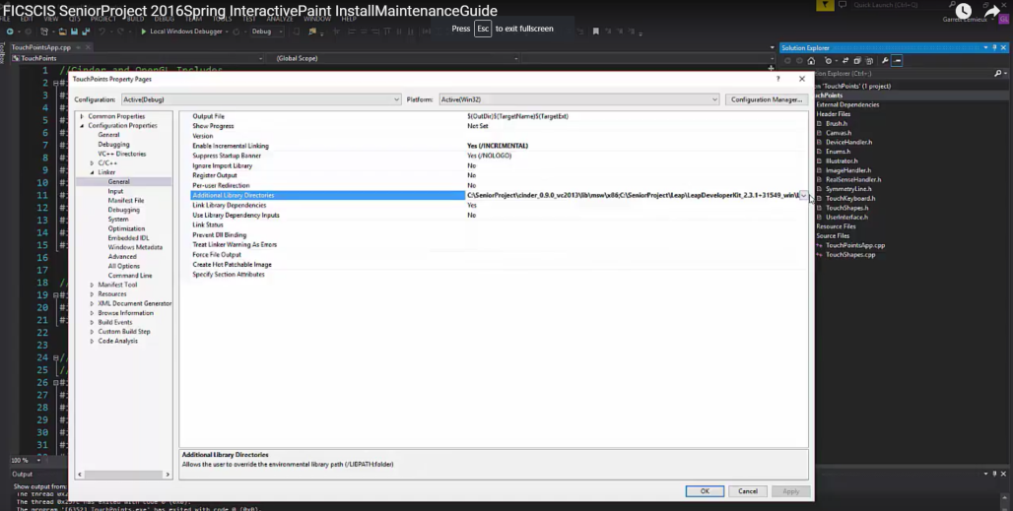

* Click button shown above to edit and add the following libraries
  + C:\SeniorProject\cinder_0.9.0_vc2013\lib\msw\x86
  + C:\SeniorProject\Leap\LeapDeveloperKit_2.3.1+31549_win\LeapSDK\lib\x86
  + C:\SeniorProject\EyeX\lib\x86
  + C:\Program Files %28x86%29\Intel\RSSDK\lib
  + As shown below

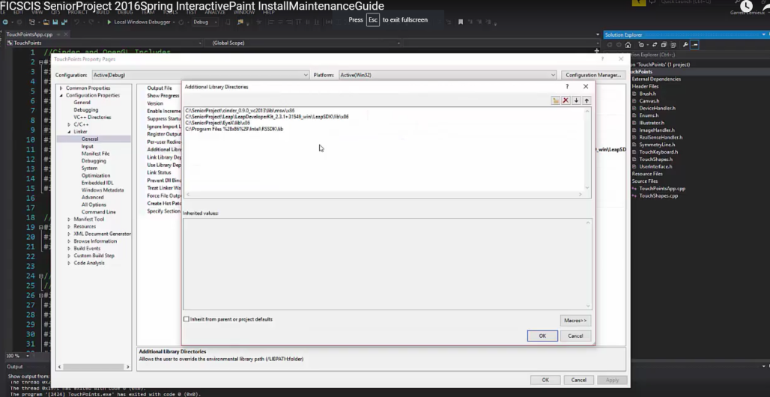

* Next we need to ignore specific default libraries
* Proceed to configurationproperties>>Linker>>Input>>Ignore Specific Default Libraries
* As shown below

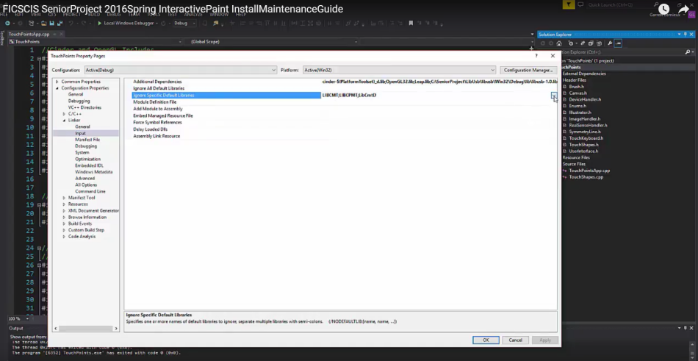

* Following need to be ignored
  + LIBCMT
  + LIBCPMT
  + LibCmtD
  + As shown below

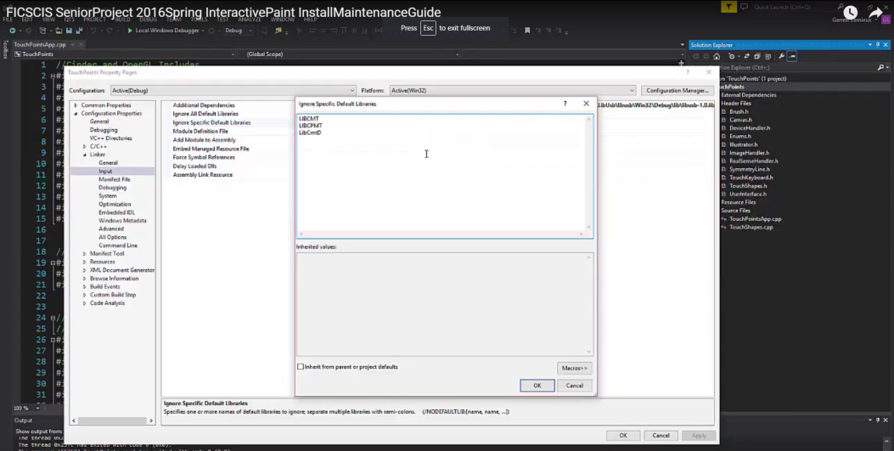

* Finally need to edit additional dependencies
* Go to configuration properties>>Linker>>Input >>Additional Dependencies
* As shown below

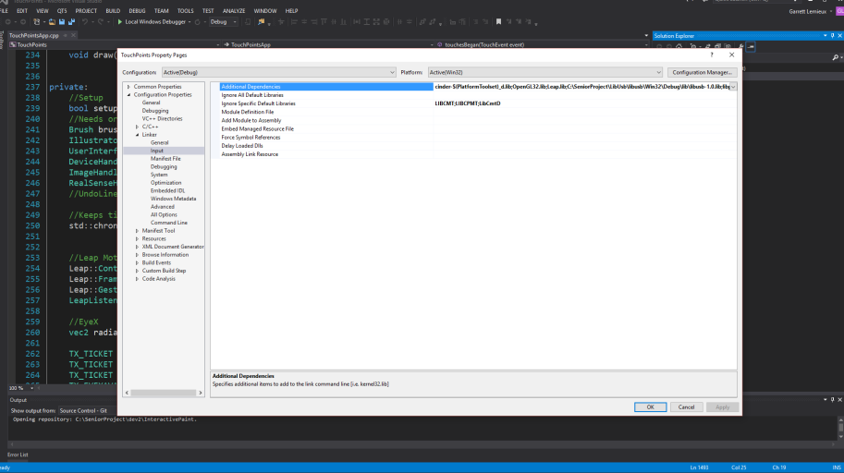

* Add the following libs
  + cinder-$(PlatformToolset)_d.lib
  + OpenGL32.lib
  + Leap.lib
  + C:\SeniorProject\LibUsb\libusb\Win32\Debug\lib\libusb-1.0.lib
  + libpxcmd_d.lib
  + As shown below

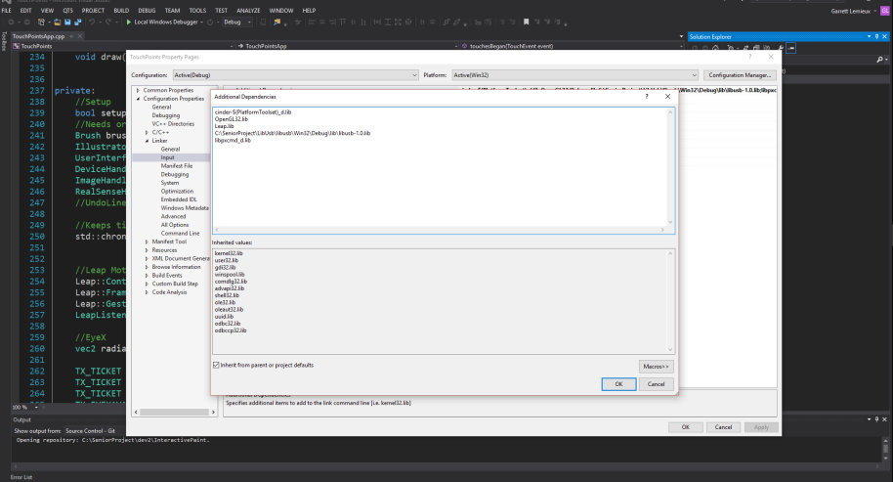

* The last thing that needs to be checked is if the following files are in the right location
  + Libpxcmd-D.lib
  + Tobi.EyeX.Client.dll
  + Leap.dll
* These need to be in the debug file in the following path >InteractivePaint>Code>TouchPoints>vc2013>Debug
* If user can’t find files search through directory using name in search bar.

**Xbox One Kinect SDK**

<https://www.microsoft.com/en-us/download/details.aspx?id=44561>

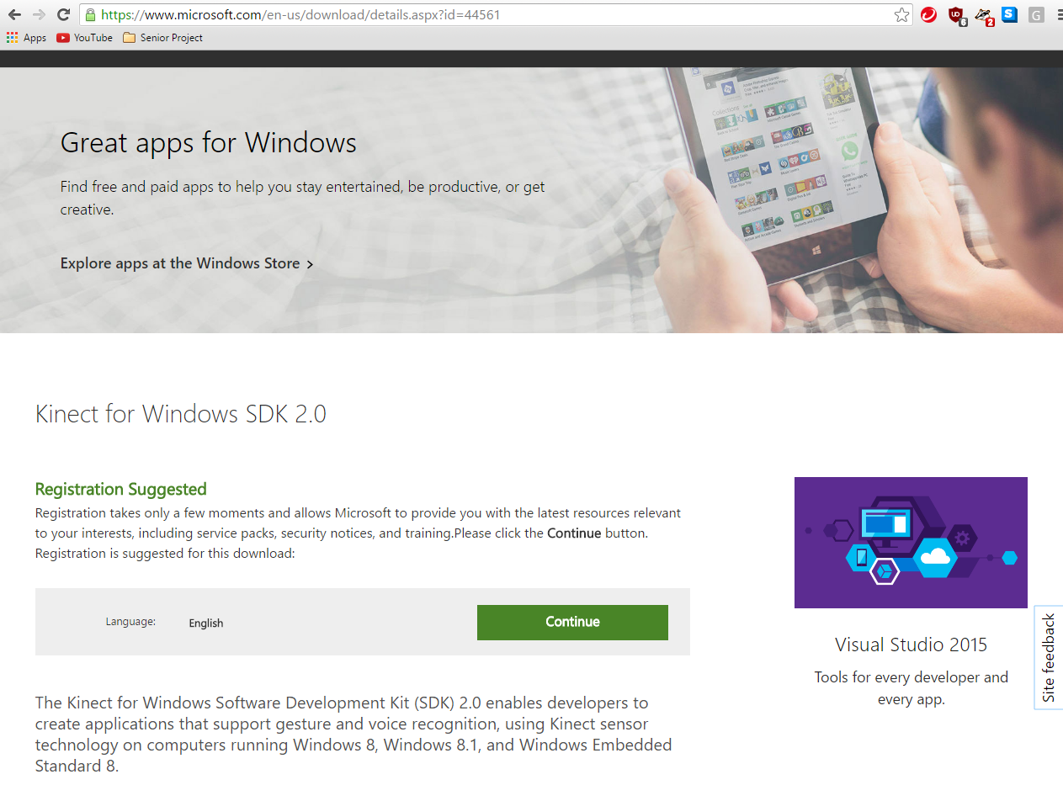

Congratulations your interactive paint program is ready to go.